Task 1: Find difference between native app and web apps.

Web apps are hosted on the web server where as native apps are explicitly installed on the user computer.

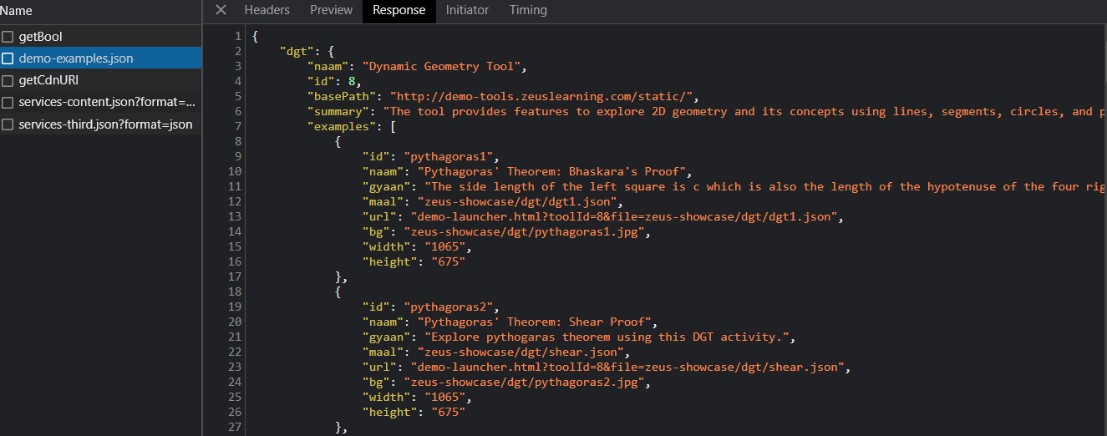

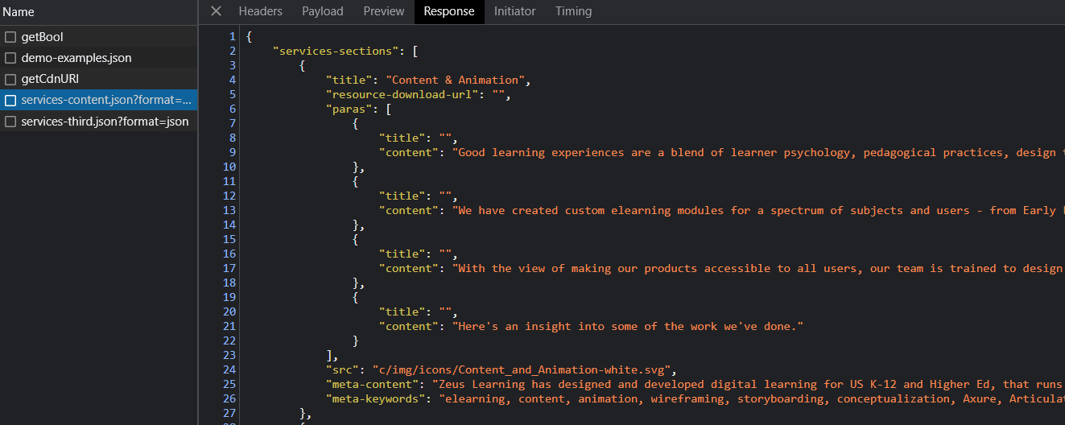

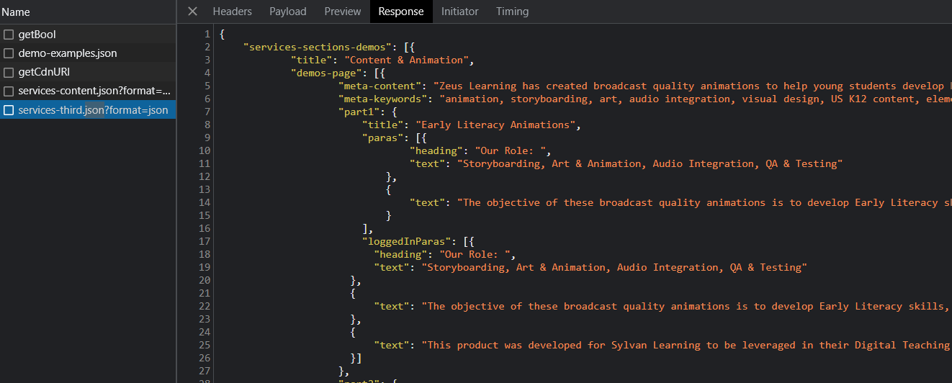

There are two more files which contains boolean value and URL

Task 3: Find out what is the better way to transport data between XML and JSON or both are the same?

JSON is a better way for transferring data which is easy to create and programming independent.